Board Endorsed Slate for 2013 Annual Meeting Selected

Preparations have begun for the 2013 Annual Meeting of Shareholders. The 2013 Nomination Committee is comprised of shareholders Gloria Bishop, Kodiak, Shannon Johnson, Anchorage and Sharon Franklin, Seattle, Washington and Board members, Perry Eaton and Michael Pestrikoff. The Committee reviews applications, conducts interviews and provides the board with their ranking of the individuals who wish to be considered for the Board endorsed slate.
Based on the Nomination Committee rankings, the Board selected the following candidates for the Board Endorsed Slate:

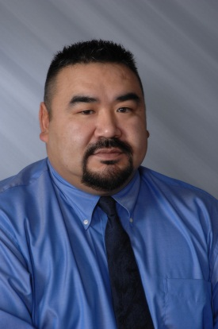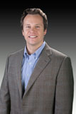
Conrad Peterson Ron Unger Amber McDonald

